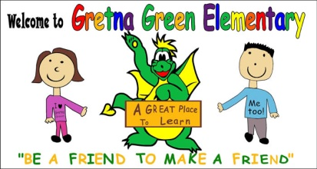
Gretna Green Elementary School
15 Gretna Green Drive

Miramichi, NB
E1V 5V6

Principal: Keith Comeau Vice-Principal: Krista Bransfield
Phone: 506 778-6099 * Fax 506 778-6143

MEMO TO PARENTS
RE: GRADE 4B

Welcome to another school year here at Gretna Green! My name is Krista Bransfield and I’m excited to be your child’s teacher for the upcoming school year.

Teachers
This year I will be teaching all classroom subjects with the exception of Science. Mr. Keith Comeau will be our Science teacher this year. Mr. Brandon Ryan will teach PE and Mr. Andy Stewart, our Guidance Counselor, will instruct weekly Guidance classes.

Timetable
Parents are reminded that class starts at 8:10. Students should be in their classrooms at this time. We break for recess at 9:45 and resume class at 10:00. Lunch is from 11:40 to 12:25. Students are in the cafeteria from 11:40 to 12:00 and outside from 12:00 to 12:25. Classes are dismissed at 2:25.

Homework
Homework is assigned for the week. On Monday, students will be assigned a Reading Comprehension activity, a Writing lesson, and a Math practice lesson. Students will also be expected to read for at least 20 minutes every night. Homework will be due on Friday. The weekly homework may be modified if the week is a short one or if students have other tests or assignments to complete. Students may be asked to finish classwork at home if it is not finished in class. As well, students may be assigned projects from time to time. Homework details will be posted on the class page on the school website (gretnagreen.nbed.nb.ca)

Physical Education
Students have PE every day from 12:45 to 1:15. Please make sure that your child has the appropriate footwear in order to participate.

Library
Students will be visiting the library on Mondays. They must return (or renew) their books at this time in order to sign out new books.

Assessments
This year we will be writing the Grade 4 Provincial Literacy Assessment at the end of May. There are two components to the testing, Reading Comprehension and Writing. In years past, grade 4 students also wrote two district assessments, one in Mathematics and one in Science. I have not yet received word on the status of these assessments for this year.

Weekly Logs
I will be sending home a weekly log on Fridays. The log consists of a checklist informing parents of their child’s behaviours and work habits for the week. There is also space for parent comments/questions.

Contact Information
If you have any questions or concerns, please do not hesitate to contact me at the school. I can be reached at 778-6099 or by email (branskrm@nbed.nb.ca).

