**Les viandes et substituts**

[](https://www.google.ca/url?sa=i&url=http%3A%2F%2Fclipart-library.com%2Fbeef-cliparts.html&psig=AOvVaw2mdhTStRcWei-Eb-2i7jW_&ust=1588093185448000&source=images&cd=vfe&ved=0CAIQjRxqFwoTCNCSsaqKiekCFQAAAAAdAAAAABAS) J’aime manger du Steak.

[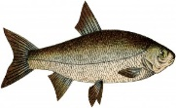](https://www.google.ca/url?sa=i&url=http%3A%2F%2Fwww.naijaheadlines.com%2Fagency%2Fnta%2F20170412%2F1877754%2Fnigeria-loses-n9-bn-revenue-annually-to-illegal-fish-importation-association&psig=AOvVaw1WszVck-k4fHzEpExBq4FT&ust=1588093062905000&source=images&cd=vfe&ved=0CAIQjRxqFwoTCOiz-_GJiekCFQAAAAAdAAAAABAR)J’aime manger du poisson.

[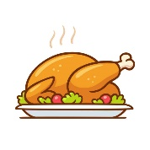](https://www.google.ca/url?sa=i&url=https%3A%2F%2Fwww.istockphoto.com%2Fillustrations%2Froast-chicken&psig=AOvVaw3EJ-pSvs0zWipu0uaP_gTt&ust=1588092985813000&source=images&cd=vfe&ved=0CAIQjRxqFwoTCPil9MaJiekCFQAAAAAdAAAAABAJ)J’aime manger du poulet.

[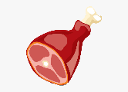](https://www.pngitem.com/middle/bRThm_ham-bacon-clip-art-meat-beef-meat-vector/)J’aime manger du jambon.

[](https://www.google.ca/url?sa=i&url=http%3A%2F%2Fclipart-library.com%2Fegg-cliparts.html&psig=AOvVaw3h1FCA-AwMlsu1fOc84_gC&ust=1588092894361000&source=images&cd=vfe&ved=0CAIQjRxqFwoTCLjCsJuJiekCFQAAAAAdAAAAABAD)J’aime manger un oeuf.