Physical Education and Mental Well-Being Activities
Week 1: Monday April 6th to Thursday April 9th
Hi Gators!
Mr. Ryan and Mrs. Barton put together a activities for you to use during extra time at home to work on your physical and mental well-being, in order to become the best you that you can be. As tempting as it can be to become one with the couch, you will feel healthier and happier after spending at least 30 minutes per day being active.
Each week, you will find a new challenge and new activities posted on your homeroom teacher’s Teacher Page on our school website at http://gretnagreen.nbed.nb.ca/.
Remember, you can be physically apart but active together. Facetime your friends, send a Snap, or make a TikTok while doing these activities to motivate each other.
We would love to see what you choose to do to stay mentally and physically well. Please feel free to send a photo or video to chris.walsh@nbed.nb.ca so we can showcase how you are staying active on the Gretna Green Facebook page.
Please find below the activities you may choose to incorporate you’re your schedule this week to stay fit! Take care and we look forward to seeing you again soon!
- Mr. Walsh

Week 1 Challenge: Your full name is the workout! Use your first, middle and last name to complete the exercises. Challenge the members of your household to do this with you to make it even better. Don’t forget to stay hydrated. If there is an exercise you do not know how to do, substitute it for one you do.
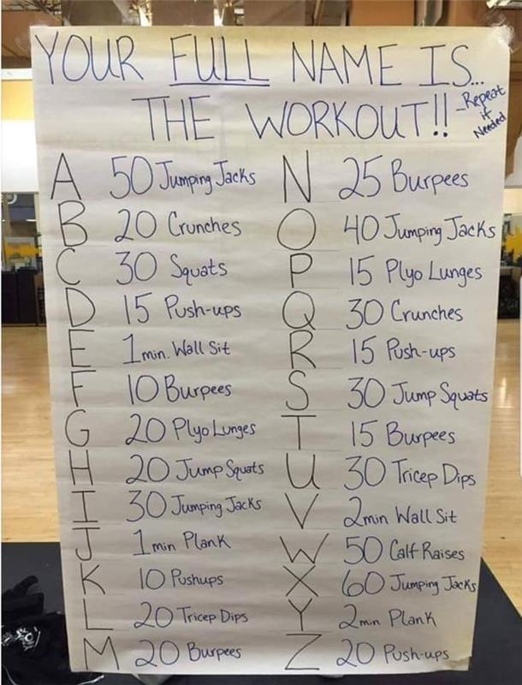

Week 1 Activities: Complete Gator Bingo. Do at least 1 to 2 activities daily. Mark completed activities with an “X”. By the end of the week, see how many lines you’ve made.

GATOR BINGO

B | I | N | G | O
Go for a 30 minute walk. | Help make lunch or supper. | Drink eight glasses of water in a day. | Dance to five Just Dance songs on YouTube. | Clean your room.
Do Zumba. (link at bottom) | Meditate for five minutes. (link at bottom) | Vacuum your house. | Complete a puzzle. | Have a plank contest with somebody.
Call a friend or family member to check in. | Play a board game with family. | FREE | Complete a physical activity of your choice. | Do a stretching routine. (link at bottom)
Build a fort inside or outside. | Shoot, kick, throw, etc. a ball outside for 15 minutes. | Make yourself or your family a healthy snack. | Do a H.I.I.T. workout. (link at bottom) | Learn a new TikTok dance.
Send a picture (through email) to Mrs. Tozer of you participating in a physical activity. | Journal your thoughts. | Do beginner yoga. (link at bottom) | Get 60 minutes of physical activity in a day. (Can be broken up throughout the day) | Do a 20 minute H.I.I.T. dance. (link at bottom)
Links:
- Do Zumba. (https://www.youtube.com/watch?v=bm4WZyH5p2I&t=185s)
- Meditate for five minutes. (https://www.youtube.com/watch?v=inpok4MKVLM)
- Do beginner yoga. (https://www.youtube.com/watch?v=v7AYKMP6rOE&t=616s)
- Do a H.I.I.T. workout. (https://www.youtube.com/watch?v=cZnsLVArIt8)
- Do a stretching routine. (https://www.youtube.com/watch?v=h2aBPh_2eEo)
- Do a 20 minute H.I.I.T. dance. (https://www.youtube.com/watch?v=lDA8QqF5gtM)

