Physical Education and Mental Well-Being Activities
Week 2: Tuesday April 14th to Friday April 17th
Remember, you can be physically apart but active together. Facetime your friends, send a Snap, or make a TikTok while doing these activities to motivate each other.
We would love to see what you choose to do to stay mentally and physically well. Please feel free to send a photo or video to chris.walsh@nbed.nb.ca so we can showcase how you are staying active on the Gretna Green Facebook page.
Please find below the activities you may choose to incorporate you’re your schedule this week to stay fit! Take care and we look forward to seeing you again soon!
- Mr. Walsh
Week 2 Challenge: Deck of Cards Workout: 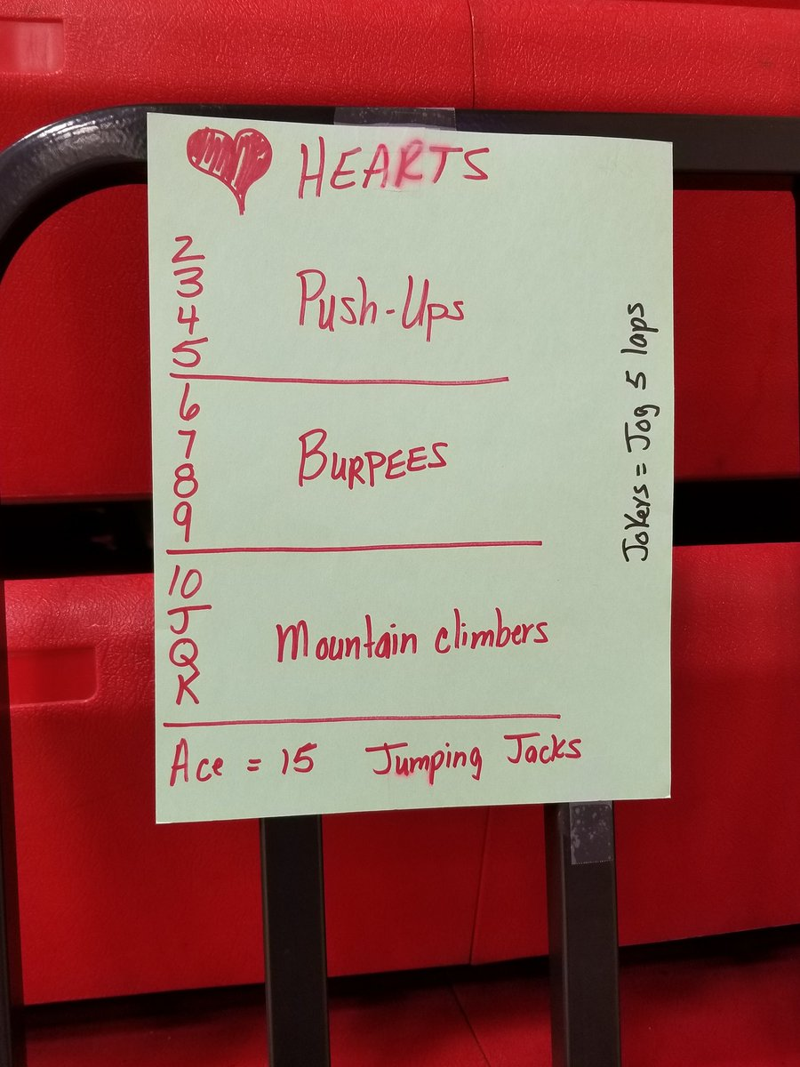

Week 2 Activities: Go for a walk and check off as many as you can from the list below:
