Physical Education and Mental Well-Being Activities
Week 6: Monday May 11th to Friday May 15th
Below are the activities/challenge you may choose to incorporate into your schedule this week to stay fit! Remember to stay active and wash your hands!!
Mr. Walsh Week 5 Challenge: 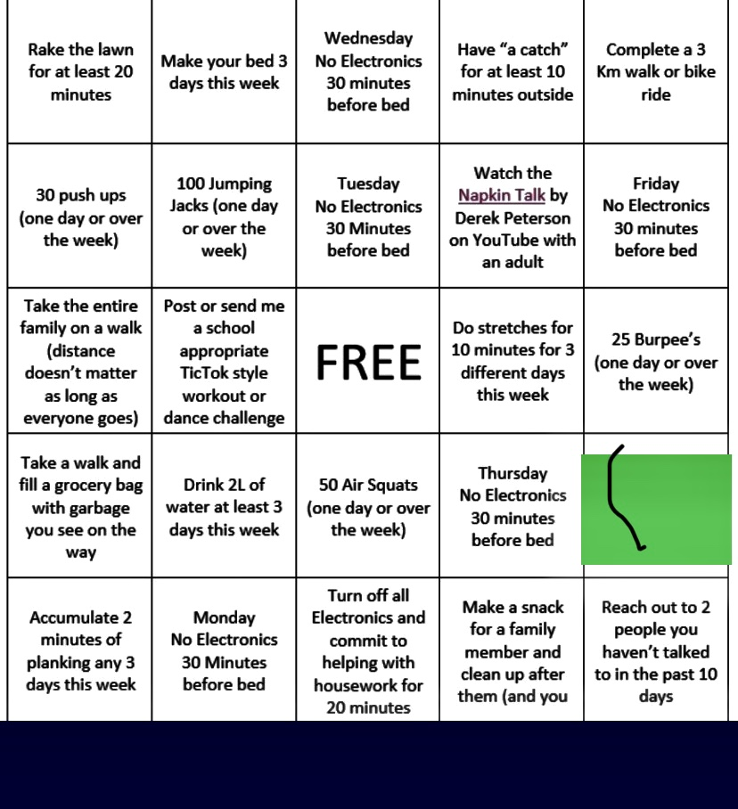
Mental Wellness Reminder:

