Physical Education and Mental Well-Being Activities
Week 8: Monday May 25th to Friday May 29th
Below are the activities/challenge you may choose to incorporate into your schedule this week to stay fit! Remember to stay active and wash your hands!!
Mr. Walsh Week 8 Challenge:
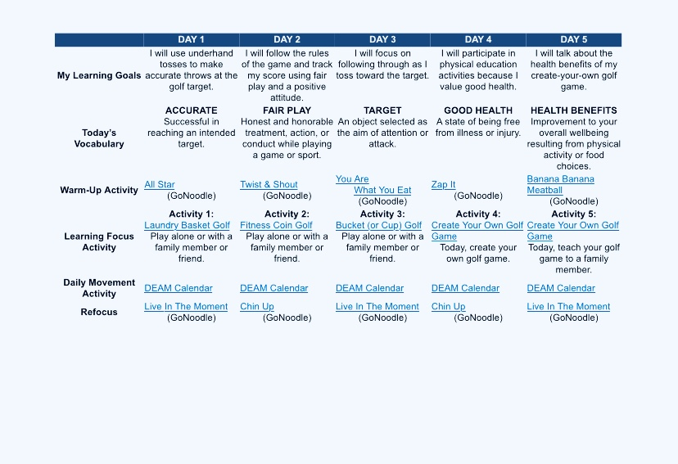

Mental Wellness Reminder:

