**Mon Souper**

Je mange du Poulet au souper. [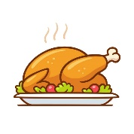](https://www.google.ca/url?sa=i&url=https%3A%2F%2Fwww.istockphoto.com%2Fillustrations%2Froast-chicken&psig=AOvVaw3EJ-pSvs0zWipu0uaP_gTt&ust=1588092985813000&source=images&cd=vfe&ved=0CAIQjRxqFwoTCPil9MaJiekCFQAAAAAdAAAAABAJ)

Je mange du riz au souper. [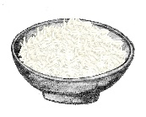](https://www.google.ca/url?sa=i&url=https%3A%2F%2Fclipartstation.com%2Fclipart-rice-10%2F&psig=AOvVaw01_fHfY2iP_1nEdlqKYkAC&ust=1590439590630000&source=images&cd=vfe&ved=0CAIQjRxqFwoTCJjGy7SvzekCFQAAAAAdAAAAABAg)

Je mange des carottes au souper. [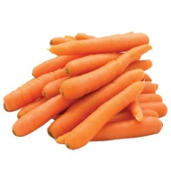](https://www.google.ca/url?sa=i&url=http%3A%2F%2Fatom-market.com%2Fproduit%2Fcarotte%2F&psig=AOvVaw2LVFCL439ru8X6iIpk2sVL&ust=1590439738316000&source=images&cd=vfe&ved=0CAIQjRxqFwoTCLj2oPivzekCFQAAAAAdAAAAABAJ)

Je bois du lait au chocolat au souper. [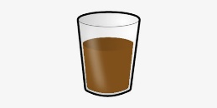](https://www.google.ca/url?sa=i&url=http%3A%2F%2Fclipart-library.com%2Fchocolate-milk-clipart.html&psig=AOvVaw1vzDIQLWIA_LxNa3zYS6fY&ust=1590439825153000&source=images&cd=vfe&ved=0CAIQjRxqFwoTCIi-z5qwzekCFQAAAAAdAAAAABAK)