Welcome to First Grade
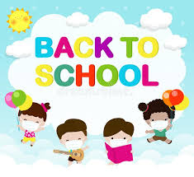

Welcome first graders! I am so excited that I get to be your child’s teacher this year. You will not believe how much your son or daughter will learn and how much fun we will have along the way.
Even though this school year may look a little different than others, we as a school are prepared to face any challenges that may arise. I will make sure that all protocol is followed to ensure your child’s safety. It would be great if you could send two clean masks each day to school. Things may not be simple, but just remember we are all in this together.
A folder will be sent home beginning today and expected to be returned each day as this is our primary way to communicate with our families. Be sure to check your child’s home folder daily and our website weekly. I will have important notes and documents on both.

You are invited to phone or email me at any time that you have a question concerning your child's progress. I will keep you informed by sending home sampling of your child's work.
Sincerely,
Paula Matchett

