“Having fun isn’t hard when you’ve got a library card!”
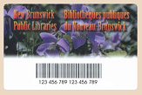

5T is very invested in our three-month reading challenge. To give students access to a world of FREE books, I highly encourage all members of our class to sign up for a library card. You can do so without ever leaving the comfort of your home! Physical books can be borrowed from the library OR eBooks from the OverDrive app.

Click the link below to fill in the online application form, then wait for the card to be mailed to your home.

https://www1.gnb.ca/0003/pages/en/car-e.asp?_ga=2.257247565.756556259.1610378106-1344126326.1601242311

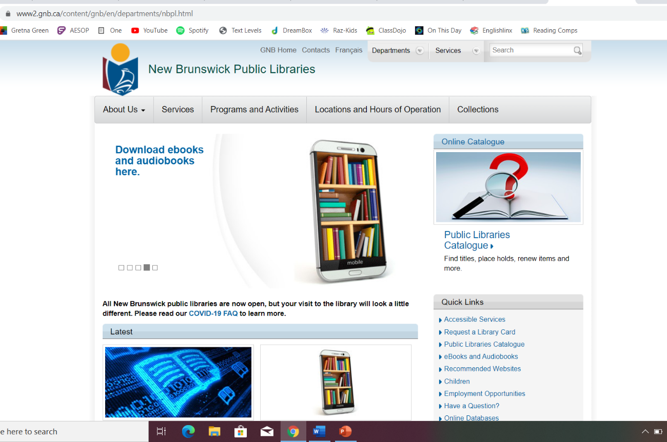

To download the OverDrive app, go to your device’s app store. Once downloaded, select your local library’s name (Newcastle, Chatham, etc.) and type your library card number.
An internet connection or data is needed to check out and download a book to your device. After it is downloaded, you no longer need an internet connection to read it.
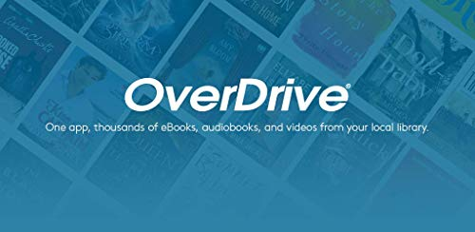

This app can be used on computers, tablets, cell phones, etc. and has a wide variety of eBooks and audiobooks.
