June
2021
Subtitle
Title  June activities | Juin 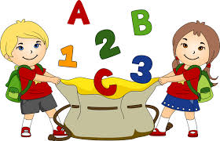
Sunday | Monday | Tuesday | Wednesday | Thursday | Friday | Saturday
 |  | 1 | 2 | 3 | 4 | 5
 |  |  | play in the school park | Blow bubbles | Crazy hair and PJ Day
6 | 7 | 8 | 9 | 10 | 11 | 12
 | Dance “Just dance: | Nature walks | Fun day | Glam day(wear nice cloth) | Wear sport cloth
13 | 14 | 15 | 16 | 17 | 18 | 19
 | Insect day(craft) | Game day | Drink Kool-Aid | Camping day | Math/science day
20 | 21 | 22 | 23 | 24 | 25 | 26
 | Bring your favorite stuffy to school | Water day | Pic-nick | Q tip tower | Las day of school year end ceremony
27 | 28 | 29 | 30

