Favorite Collection – Picture/Writing Assignment

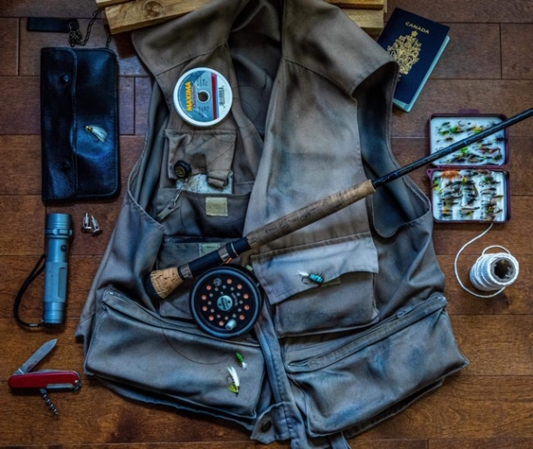
Here is a super cool way to showcase some of your favorite things. You are to think about what aspects of your topic you are going to display. For example, if your topic was a story about your Dad, you might make a list of things to put in your PowerPoint that would show others about your Dad. Then, after making the list, you will reflect on why the items are important symbols of who your Dad is as a person.

Follow these steps for creating your PowerPoint:
- Think about what your topic will be about. Make a list of items to collect that relate to your topic. Make sure they are meaningful. Choose at least 5 items.
- Put all of your items together and take a picture of them. Be creative on how you place the items.
- Write about each of your items and explain why each item is important. Be specific. For example, if you include a phone in your picture, don’t just say that you put a phone because you listen to music on your phone. Explain why the phone is an important tool for listening to music. Your items should have a story behind them. Say at least 2 or 3 things about each item. Again, be specific!
- Create a PowerPoint. This is how it will be set up:
- Page One – Title and your name
- Page Two – Picture of all of your favorite things
- Page Three/Four/Five (you may not need this many pages) – Write up about all of your favorite things
- Page Six – Any photos you want to add that relate to any of your favorite things
- You will present this to the class.
- Follow the rubric on the back. Have fun!

