Math at Home with Mrs. Allison – week 4 (Apr. 27 – May 1)
Hi Grade 1 Math kids! Welcome to week 4. I hope you are all having fun with home learning. Here are a few activities for you this week. Have fun!
Reminder -- **Reflex Math** and **Splash Math** have also been set up for all students. In order to get your child’s username and password, please email me to get it and I will gladly pass it along. If you have any questions or concerns, please do not hesitate to contact me at teena.allison@nbed.nb.ca
- For dice and card games and websites, please refer to the attachments from week 1.
Monday | Tuesday | Wednesday | Thursday | Friday
*Count from 0 to 100 forwards and backwards. To go even further, try starting at different points.  *Relfex Math or play a card game with someone you love.  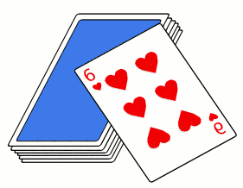 | What is 2 less than 18? What is 2 more than 18? What is 2 less than 45? What is 2 more than 45? What is 2 less than 61? What is 2 more than 61? Write them down.  *Splash Math for 15 minutes or play a game on splashmath.com | There are five apples in a bag. Some more apples were put in the same bag. Now there are 13 apples in the bag. How many apples were added to the bag? Write out your problem.  *Reflex Math or Play a dice game with someone you love. | Build two sets of objects that are equal and explain why they are equal. Draw it out.  *Splash Math or play a game on abcya.com | Count by 5’s and 10’s to 100. Write the numbers down on a piece of paper.  *Reflex Math or play a card game with someone you love.

