Math at Home with Mrs. Allison – week 5 (May 4 – May 8)
Hi Grade 1 Math kids! Welcome to week 5. I hope you are all having fun with home learning. Here are a few activities for you this week. Have fun!
Reminder -- **Reflex Math** and **Splash Math** have also been set up for all students. In order to get your child’s username and password, please email me to get it and I will gladly pass it along. If you have any questions or concerns, please do not hesitate to contact me at teena.allison@nbed.nb.ca
- For dice and card games and websites, please refer to the attachments from week 1.
Monday | Tuesday | Wednesday | Thursday | Friday
*Skip count to 50 and 100 by 2’s, 5’s and 10’s. Write the numbers down.  *Relfex Math or play a card game with someone you love.  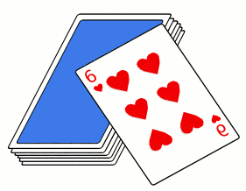 | *Use your hand to measure the length of your bed. How many hands long is it? Use something else to measure it (ie toy, book, etc. and measure again. How different are the measurements? Try and explain why.  *Splash Math for 15 minutes or play a game on splashmath.com | *How many number sentences can you make that have 14 as the answer? Write them down.  *Reflex Math or Play a dice game with someone you love. | Answer the following:  7 + ___ = 10  8 + ___ = 15  ___ + 3 = 10  ___ + 7 = 15  *Splash Math or play a game on abcya.com | *Write down all the friends of 10. (ie 1 + 9 = 10)  *Reflex Math or play a card game with someone you love.

