**PHYSICAL EDUCATION DIGITAL CHOICE BOARD**

Grade Level: 6-8  
Subject: Physical Education

**Hey Gators! Use this choice board for the next 2 weeks to help reach your 60 minutes of daily physical activity. Don’t forget to log your activity in your Activity Log.**

|  |  |  |
| --- | --- | --- |
| **Obstacle Course**  Design your indoor or outdoor obstacle course | **Just Dance** Get your heart beating and dance using Youtube Just Dance videos. Aim for 15 minutes per day.  Cute happy children girls and boy dancing cartoon Vector Image | **Spell Your Name Fitness.**  Spell out your name and do the activities that go with each letter. See directions below. |
| **Fitness Bingo**  Follow the link below  and play a game of Fitness Bingo!  A Fun Fitness Bingo Game: Workout Rules & Cards | **Cosmic Yoga**  Go to [Cosmic Yoga](https://www.youtube.com/c/CosmicKidsYoga) and choose a yoga routine. Try to do 3-5 routines each week. | **Flip a Coin Workout**  Flip a coin and whatever it lands on is the exercise you complete!  Fitness Friday Flip A Coin |
| **Phone Number Workout**  Use your phone number to create your own custom workout  **Phone Number Workout #squats #exercise #fitness #planks | Fun workouts, At  home workout plan, Elementary pe** | **Fitness Shuffle**  Use half a deck of cards. Draw one card and see what exercise you get to do! See directions below. | **Winter Challenge**  How many winter activities can you do in 2 weeks? See list below. |





**Fitness Bingo**

<https://www.performancehealth.com/media/wysiwyg/blog/articles/FitnessBingo_1.pdf>

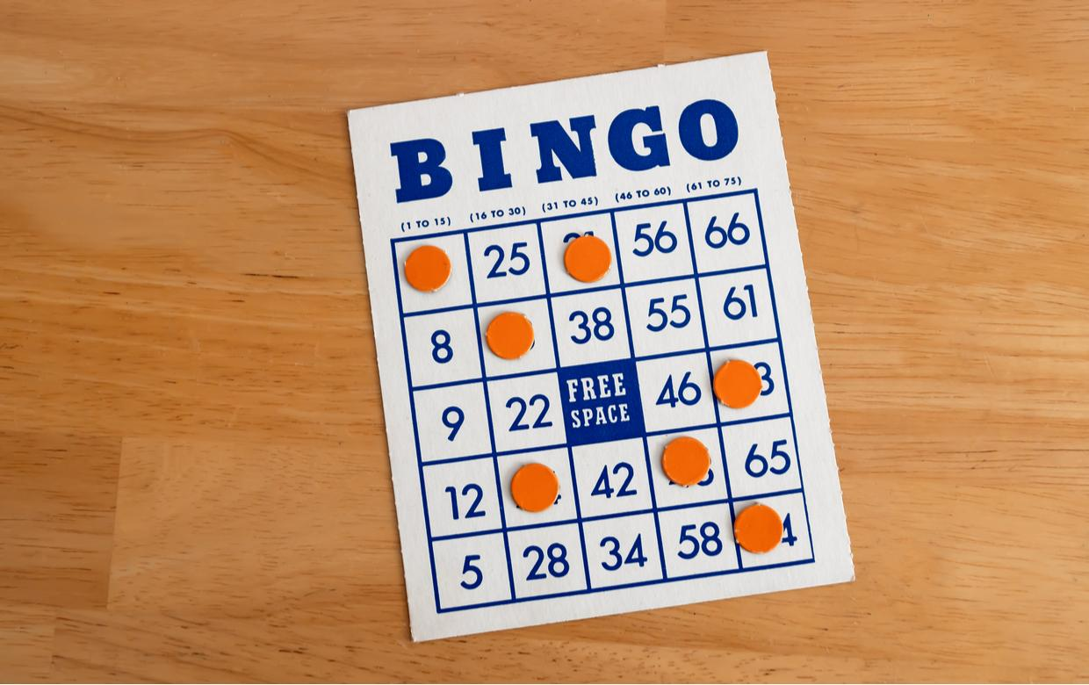





**Flip a Coin Workout**

Do each exercise for 30 seconds before flipping again. Try to complete as many loops as possible.

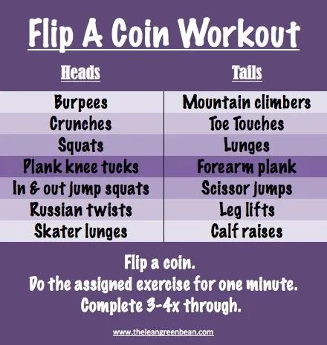

Winter Challenge Checklist

Go Sledding.

Go skating on an outdoor rink

Build a snowman

Build a quinzhee or snowfort

Go snowshoeing

Go cross country skiing

Build a snow sculpture

Go on a winter hike

Build an outdoor fire (have a parent help)

Cook lunch/supper over an outdoor fire.

*If you are looking for more fun winter activities, check out this website. <https://kidactivities.net/games-play-snow/>

**Phone Number Workout**

