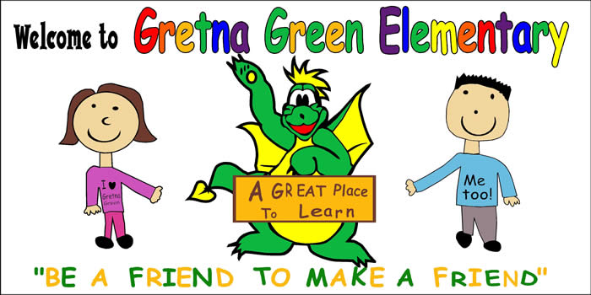
Gretna Green Elementary School
15 Gretna Green Drive

Miramichi, NB
E1V 5V6

Principal: Rodney Buggie Vice-Principal: Keith Comeau
Phone: 506 778-6099 * Fax 506 778-6143




2011

Welcome Back & Thank You!

We would like to wish you all the best in 2011 We would also like to thank everyone who sent in goodies, presents and best wishes for the season to our staff. Your generosity is appreciated.


Basketball

Basketball will start again January 11th. Grade 4-5 games have been scheduled and will start on January 17th. Games will be posted on the website calendar.

Home & School

Our Home & School meeting will be held on January 12th at 6:00 p.m. in the cafeteria. We will be discussing our upcoming P.J. Literacy Party.

The Home & School will hold its annual Home & School P.J. Literacy Party on Thursday, January 27th at 6:30 p.m. in the school gym. Staff members and Home & School members will share their favourite stories with the children. There will be cookies and milk in the cafeteria following the stories. Students must be accompanied by an adult.

School Fundraiser for December

We would like to congratulate Mr. Leo Ross, grandfather of Gillian, Katie and Jenna Kennedy, on winning the Oak Storage Bench and assorted crafts that was raffled off at the Christmas Concert. We would like to thank everyone who purchased tickets and donated crafts to this worthwhile project.

Come in Character Day

To mark Family Literacy Day, we will have a “Come in Character Day” on Wednesday, January 26th. Students are encouraged to dress up as their favourite character from a good book on that day. Characters in Robert Munch books are usually a fun and easy way to dress up without having to spend a lot of money. Your child’s class will be participating in the fun literacy activities with their buddy class.

Parents or grandparents are invited to visit the school this week to read to a class, a small group or individual. If you are interested in this, please call Mr. Buggie or Mr. Comeau at
778-6099 to make arrangements. Children love to hear their favourite book being read to them.

Important Reminders
!
We want to remind parents to please stop for the red flashing lights on the school busses when entering the school parking lot before and after school. Also, please do not drop your children off at the school before 7:50 a.m. No supervision is available until after this time. Your cooperation with these matters is greatly appreciated.

Staffing

We would like to welcome Miss Elaine Murray to our staff. She is replacing Grade 1 teacher Mrs. Christine O’Toole who is out on maternity leave. Also, we would like to welcome
Miss Rebecca Hitchman. She is replacing grade 4 teacher Ms. Krista Bransfield, who is also on maternity leave. Grade 3 French Immersion teacher Mr. Keith Comeau has accepted the position of Vice Principal while Ms. Bransfield is away. We have a new student teacher on staff as well. Mrs. Carla Pitre will be with Mrs. Judy Gallant’s Grade 5 class until April.

New Arrival

Ms. Krista Bransfield and her husband Randy, along with their first son Samuel welcomed their baby boy in January. Henry Robert McLean was born on January 7th at the Miramichi Hospital and both mom and baby are doing great. Congratulations to you and your family Ms. Bransfield!

Storm Line Phone Number

This is a reminder that District 16 has a “Snow Line” you can call if you are wondering about school cancellations during inclement weather; call 778-SNOW (7669).

Christmas Concert DVD

We still have the 2010 Christmas Concert DVDs available for anyone interested in purchasing one. The cost is $7.00 per DVD. Please send a note to your child’s teacher if you are interested or contact Mrs. Clark at the school.

Grade 5 Bottle Recycling

Just a reminder to take your recyclable bottles to Hebert’s Bottle Exchange in Chatham. The Grade 5 class has an account set up with Hebert’s that will allow friends and family to donate their money from their recyclables to help the Grades 5s with their end of the year trip to Moncton. Thank you for help!

Remember to check out our website for
updates, notices, class pages, calendars, newsletters and daily announcements!

gretnagreen.nbed.nb.ca


