Gretna Green Winterfest 2019
February 25-March 1

Monday, February 25th
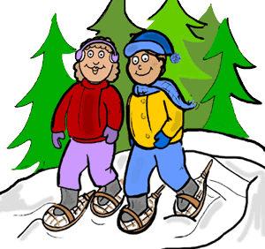
- Theme Day – Twin Day
- Grade 2 – Skating 9:30-10:30
- Grade 1 – Skating 11:15-12:15
- Kindergarten – Sliding 11:15-12:15
- Grade 3G & 3/4 Y– Skating 1:00-2:00

Tuesday, February 26th
- Theme Day – GG Spirit Day (Dress to impress in Gretna Green colours, black and green!)
- Grade 5 – Cross Country Skiing and Snowshoeing @ Miramichi Ski Club 9am-12pm
- Kindergarten – Skating 11:00-12:00
- Grade 2 – Sliding 1:20-2:00
- Grade 1 – Sliding 11:00-12:00
- Grade 4S – Skating

***Family Activity Night (Tuesday, February 26) 6pm-8pm
Skating, Sliding, snowshoeing and bonfire !!!
Please bring your skates, sleds, snowshoes & headlamps.***

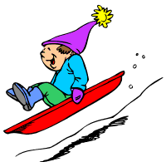
Wednesday, February 27th
- Theme Day – Wacky Sock Day (Wear your craziest pair of socks!)
- Grades 3&4 – Curling at Curling Club & Sliding at French Fort Cove 9-11:30
- Grades 6-8 – Curling at Curling Club 12:15-2:00
- Grade 5 – Sliding 12:45-1:45

Thursday, February 28th
- Theme Day – Sports Day (Wear a clothing item to support your favorite team!)
- Middle School Cup Tournament on outdoor rink
- K-5 Outdoor Activity Day 12:45-2:10
- Snowman Sculpture winner announced.

Friday, March 1st
- Theme Day K-8 – PJ Day (Enjoy a cozy day in your pajamas!)
- Grade 5 –Skating 10:45-11:45
- Varsity Boys vs Varsity Girls Basketball Game – 1:30pm
GG Buttons
Gretna Green Buttons will be on sale this week at lunch for $2.00/button.

Snow Sculpture Contest
Let's make a Snow sculpture! The winter season brings with it a variety of great activities to promote a healthy living style. Making a snow sculpture is just one of them! In an effort to promote healthy living at GG; we will be hosting a variety of outdoor activities for our students during the month of February. To kick things off, we will be having a snow sculpture building contest for the month of February. Simply build a snow sculpture at home and email a photo of your cool looking snow sculpture to Mr. Ryan at brandon.ryan@nbed.nb.ca. These photos will be posted at school and a vote will be held for the nicest looking snow scultpure. Winners will be announced February 28th.

